# Subject: 20CS2036L – Web Technology Lab

**Lab Exercise: 4. Design a Sign-In and Sign-Up Page with Navigation Bar using CSS (Duration: 1.30 hours)**

**Create a web page with Sign-In and Sign_up form including horizontal navigation bar for any organization/industry as per your choice using HTML and CSS features such as CSS Position, Form Styles, CSS Pseudo classes that conforms to the following guidelines.**

* You need to design a single page website with horizontal navigation bar, Sign In and Sign Up forms, image and table design with necessary CSS properties.
* Create an external CSS file with extension .css and include it in HTML program using <link> tag.
* Use pseudo class like focus and hover effects with form elements, image, table, button and navigation items.
* Use the mockup illustration page given below - create your unique design with background images and colors, etc..
* Publish your website live on the web using some free web hosting services (000webhost)

**Navigation bar**

Make a fixed rollover effect on horizontal navigation bar using list of links. Remove the bullets of the link and remove the default text declaration from the links. Display the links as block elements and specify width and background color. This navigation bar should stretch the full width of the screen. The navigation elements themselves should still be centered over the content area.

Apply the following text properties: Font- family : Helvetica Font-weight:bold

Text -color : #ffffff; on mouse over(color: rgba(255,255,255,0.5)) Background color: rgba(255,255,255,0.5) on hover (#dff0d8;) Initially the navigation bar should be transparent (set opacity)

**Sign In and Sign Up forms**

Design a Sign-In and Sign-Up Box with necessary Input form elements with unique design (think some innovative design) and position the box using relative or absolute in the page.

**Rounded corner Image with hover effect:**

Have a division over the image and when user moves the mouse pointer over it (use :hover pseudo class) change the opacity of the division to 0. Thus, the image placed behind that division will be made visible.

Give box shadow effect to the division and image; box-shadow: h-shadow v-shadow blur color

eg: box-shadow: 10px 10px 5px #888888;

Give rounded corners to the div and the image, by using the border-radius property. Eg: border-radius: 50%;

**Table design**

Display the item in table format. Add set the following styles.

* Select the adjacent sibling and apply style
* Table has 2 columns. Display item names in the 1st column and the corresponding images in the next column. Initially set hide all the images and on hover of the item name make the image visible by changing the opacity into 1.

Sample code for reference

<table ><tr><td class="itemName">item1</td>

<td class="itemImg"><img src="item1.jpg" ></td></tr> </table>

.itemImg{ opacity :0.2; }

.itemName:hover + .itemImg{ opacity: 1; }

Hint: itemName and itemImg are adjacent sibling. On hover of itemName select its adjacent sibiling itemImg.

Set different colors for odd and even rows and change the background color on mouse over. [hint: nth- child(odd) and nth-child(even)]. Give rounded corners to the table [use the border-radius property.]

**SOURCE CODE:**

## 1 -- index.html

<!DOCTYPE html>

<html lang="en">

<head>

<meta charset="UTF-8">

<meta name="viewport" content="width=device-width, initial-scale=1.0">

<title>Document</title>

<link rel="stylesheet" href="style.css">

</head>

<body>

<div class="n1">

<ul>

<li class="logo-"><a href="index.html">SWIMMING CLUB</a></li>

<li><a href="index.html"><h3>Home</h3></a></li>

<li><a href="details.html"><h3>Details</h3></a></li>

<li><a href="price.html"><h3>Pricing</h3></a></li>

</ul>

</div>

<div class="forms">

<form action="action_page.php" method="post">

<h2> Sign In</h2>

<div class="container">

<label for="uname"><b>Username</b></label>

<input type="text" id="uname" placeholder="Enter Username" name="uname" required>

<label for="psw"><b>Password</b></label>

<input type="password" id="psw" placeholder="Enter Password" name="psw" required>

<button type="submit">Sign In</button>

</div>

</form>

<form action="action_page.php" method="post">

<h2> Sign Up</h2>

<div class="container">

<label for="uname_signup"><b>Name</b></label>

<input type="text" id="uname_signup" placeholder="Enter Username" name="uname" required>

<label for="uemail"><b>Email</b></label>

<input type="email" id="uemail" placeholder="Enter Email" name="uemail" required>

<label for="psw_signup"><b>Password</b></label>

<input type="password" id="psw_signup" placeholder="Enter Password" name="psw" required>

<button type="submit">Sign Up</button>

</div>

</form>

</div>

</body>

</html>

# – details.html

<!DOCTYPE html>

<html lang="en">

<head>

<meta charset="UTF-8">

<meta name="viewport" content="width=device-width, initial-scale=1.0">

<title>Document</title>

<link rel="stylesheet" href="style.css">

</head>

<body>

<div class="n1">

<ul>

<li class="logo-"><a href="signup.html">STYLES </a></li>

<li><a href="index.html"><h3>Home</h3></a></li>

<li><a href="details.html"><h3>Details</h3></a></li>

<li><a href="price.html"><h3>Pricing</h3></a></li>

</ul>

</div>

<img src="free.jpeg" alt="Free Style">

<img src="backst.jpeg" alt="Back Stroke" >

<img src="butterfly.jpeg" alt="Butterfly">

<div id="a1" >

<h1>Free Style</h1>

<h1>Back Stroke</h1>

<h1>Butterfly </h1>

<p>The fastest stroke, characterized by alternating arm movements and continuous kicking, providing efficiency and speed in competitive swimming</p>

<p>Swum on the back, with arms rotating in a continuous motion and flutter kicking, offering a relaxed yet competitive style. </p>

<p>Intense and powerful, involving simultaneous arm movements and an undulating dolphin kick, demanding strength and coordination for propulsion.

</p>

</div>

</body>

</html>

# – price.html

<!DOCTYPE html>

<html lang="en">

<head>

<meta charset="UTF-8">

<meta name="viewport" content="width=device-width, initial-scale=1.0">

<title>Document</title>

<style>

body {

font-family: Helvetica, sans-serif, sans-serif; font-weight: bold;

color: black; margin: 0;

background-image: url('back.jpeg'); background-repeat: no-repeat; background-size: cover;

}

.logo- {

color: rgb(241, 151, 4); font-size: 1.3rem;

font-weight: 600;

font-family: Impact, Haettenschweiler, 'Arial Narrow Bold', sans-serif;

}

.n1 {

height: 15vh;

}

ul {

margin: 0;

list-style-type: none;

background-color: rgba(0, 0, 0, 0.2);

}

ul li {

display: inline-block; width: 23%;

transition: transform 0.3s ease;

}

ul li a {

text-decoration: none;

color: black;

}

ul li:hover {

transform: scale(1.1); cursor: pointer;

color: rgba(255, 255, 255, 0.4);

}

.center {

margin-left: auto; margin-right: auto;

}

table {

position: relative;

background-color: rgb(243, 192, 8);

border-radius: 5%; border-color: black; width: 45%;

box-shadow: 10px 10px 5px rgb(51, 4, 222); border-style: solid;

margin-top: 10%;

}

#r1, #r3 {

background-color: rgb(4, 232, 156);

border-radius: 5%;

}

#r1, #r2, #r3, #r4 {

width: 85%;

transition: transform 0.3s ease; border-radius: 5%;

}

#r1:hover, #r3:hover {

background-color: burlywood;

border-radius: 10%;

transform: scale(1.1);

}

img {

opacity: 0.5;

transition: transform 0.3s ease;

}

img:hover { opacity: 1;

border-radius: 10%; transform: scale(1.1);

}

tr,

th {

text-align: center;

}

tr:hover {

background-color: antiquewhite; border-radius: 20%;

opacity: 1; transform: scale(1.1);

}

tr:hover+img { opacity: 1;

}

</style>

</head>

<body>

<div class="n1">

<ul>

<li class="logo-"><a href="index.html"> SWIMMING CLUB

</a></li>

<li><a href="index.html">

<h3>Home</h3>

</a></li>

<li><a href="details.html">

<h3>Features</h3>

</a></li>

<li><a href="price.html">

<h3>Pricing</h3>

</a></li>

</ul>

</div>

<table class="center">

<tr>

<th colspan="2"> Pricing plans

</th>

</tr>

<tr>

<td id="r1">Per Hour Play</td>

<td><img src="1s.png" alt="Buy" width="100" height="50"></td>

</tr>

<tr>

<td id="r2">learn to swim</td>

<td><img src="2s.jpeg" alt="Buy" width="100" height="50"></td>

</tr>

<tr>

<td id="r3">Monthly Membership</td>

<td><img src="3s.jpeg" alt="Buy" width="100" height="50"></td>

</tr>

<tr>

<td id="r4">Annual Membership</td>

<td><img src="4s.jpeg" alt="Buy" width="100" height="50"></td>

</tr>

</table>

</body>

</html>

# Styles.css

body {

font-family: Helvetica, sans-serif, sans-serif; font-weight: bold;

color: black; margin: 0%;

border: 0%;

background-image: url('back.jpeg'); background-repeat: no-repeat; background-size: cover;

}

.n1 {

height: 15vh;

}

ul {

margin: 0%;

list-style-type: none;

background-color: rgb(0, 0, 0, 0.2);

}

ul li {

display: inline-block; width: 23%;

transition: transform 0.3s ease;

}

ul li a {

text-decoration: none; color: black;

}

ul li:hover {

transform: scale(1.1); cursor: pointer;

color: (255, 255, 255, 0.4);

}

a:hover {}

.logo- {

color: rgb(0, 0, 0); font-size: 1.3rem; font-weight: 600;

font-family: Impact, Haettenschweiler, 'Arial Narrow Bold', sans-serif;

}

form {

border: 3px solid #635c5c; background-color: rgb(99, 92, 92, 0.3); width: 320px;

margin-top: 4%;

margin-left: 16%; border-radius: 20px;

display: inline-block; position: relative; box-shadow: #ccc;

}

form h2 {

text-align: center;

}

.container label { padding-left: 5%;

}

input[type=text], input[type=password], input[type=email] { width: 80%;

padding: 20px 20px; margin: 10px; display: block;

border: 1px solid #ccc; border-radius: 15px;

}

button {

background-color: #09aeef; color: white;

padding: 14px;

margin: 8px 0 10px 60px; border: none;

cursor: pointer; width: 60%;

border-radius: 15px;

}

button:hover { opacity: 0.8;

}

img {

display: inline-block;

box-shadow: 10px 10px #d89969; border-radius: 60%;

margin-left: 9%;

opacity: 0.3; padding-top: 20px; width: 20% ; height:230px;

}

img:hover { opacity: 1;

transform: scale(1.1) rotate(-3deg);

}

h1 {

padding-left: 20%; display: inline-block; border: none; width: 30%;

height: 50px; background-color: none; padding: 10px;

box-sizing: border-box; margin-left: 2%;

font-size: 24px; font-weight: bold;

font-family: 'Segoe UI', Tahoma, Geneva, Verdana, sans-serif; color: rgb(231, 151, 3);

text-shadow: 2px black;

}

p {

padding-left: 20%; display: inline-block; border: none; width: 30%;

height: 50px; background-color: none; padding: 10px;

box-sizing: border-box; margin: 15px;

color: rgb(226, 237, 9); font-size: 20px;

}

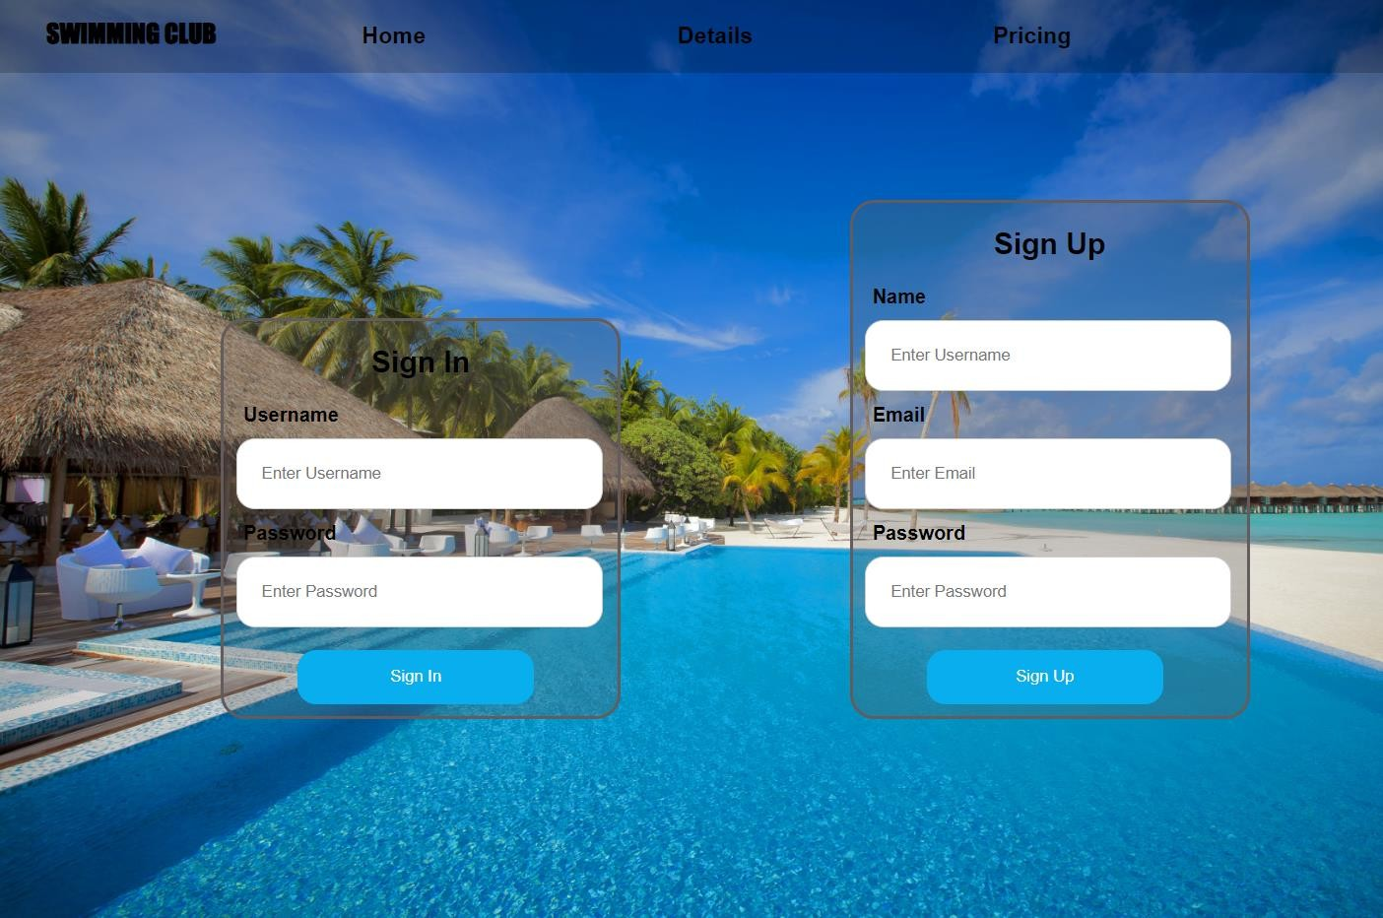

## Navigatio

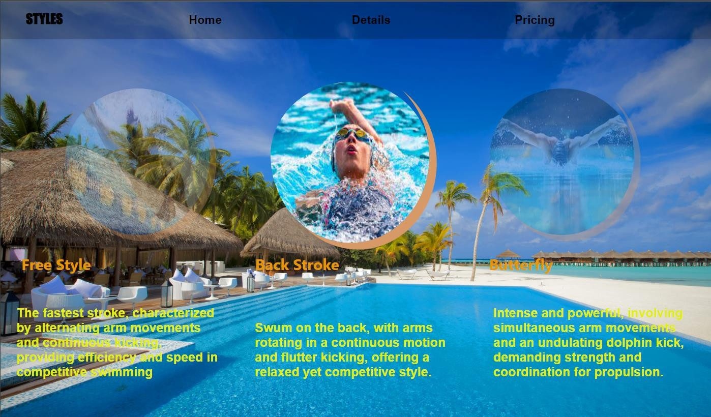

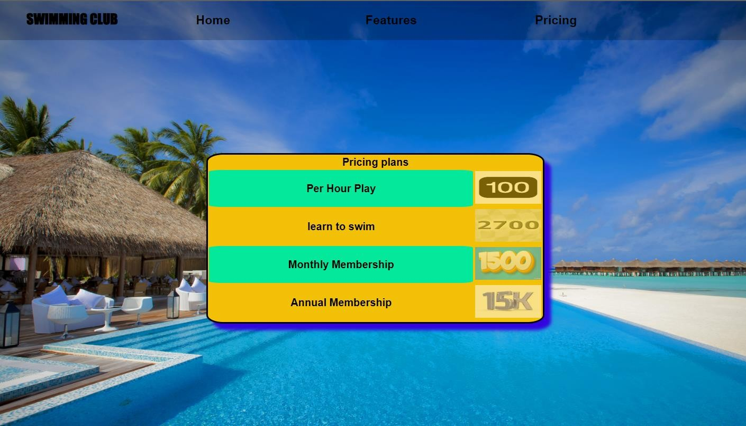

**RESULT :**

Successfully Created a stylish Sign-In and Sign-Up page with a Navigation Bar using CSS for an enhanced user experience and seamless navigation.